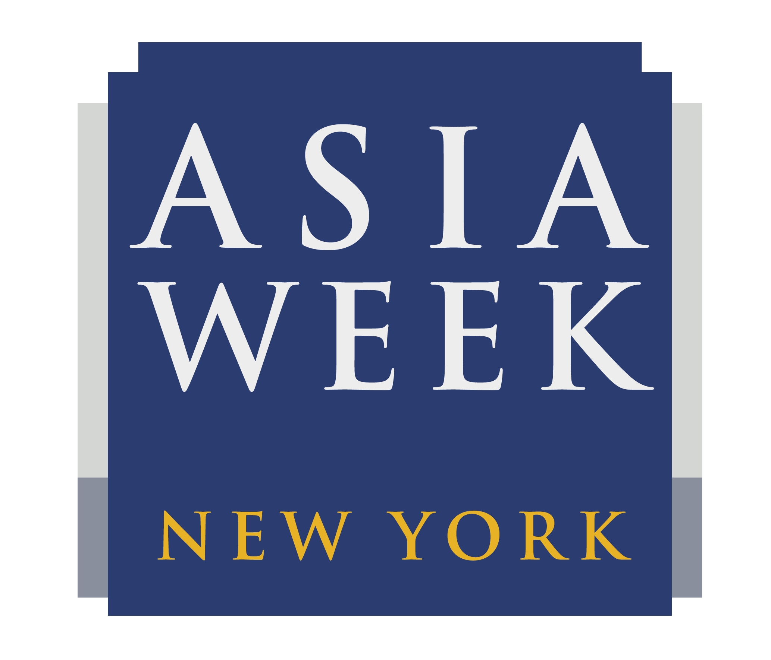

The Cosmos Within:
Contemporary Japanese Metalwork and Ceramics

Onishi Gallery: 521 West 26th Street, New York, NY 10001
Exhibition Dates: March 13-23, 2019
Opening Reception: Thursday March 14, 6-9pm
Open House Weekend: March 16-17, 11am-5pm
Hours during Asia Week: Mon-Sat 11am-6pm (otherwise by appointment)

In celebration of the 10th anniversary of Asia Week New York, Onishi Gallery is proud to present a unique new exhibition to Western audiences—The Cosmos Within: Contemporary Japanese Metalwork and Ceramics. In this collection of contemporary Japanese kōgei arts (a class of artistic creations produced in close association with the needs and conditions of everyday life), Onishi Gallery demonstrates the vast cosmos and intimate nature that may be communicated through a delicate work of art. While European arts often express the wonders of the universe through dynamic artistry, Japanese kōgei artists use subtle techniques to represent the cosmos within—imagine the world that unfolds when one looks through the small lens of a kaleidoscope.
With advanced skills and refined taste, Japanese kōgei artists address the circumstances of daily life in cities and prefectures throughout Japan, drawing upon local aesthetics and regional materials to reflect diverse social, cultural, and physical environments. Visitors to this exhibition will be immersed in a space defined by these unique Japanese art objects, as well as one designed to serve as a Japanese tea ceremony room. They will have a special opportunity to immerse themselves, visually and physically, within this cosmos.
Impressively, this year’s exhibition features 26 artists who fall into two categories based on their creative media, ceramics or metalwork. Within this talented group, 10 artists have been designated “Living National Treasures” by the government of Japan for their contributions to the preservation and transmission of traditional Japanese artistic heritage. These artists include the esteemed Nakagawa Mamoru, Osumi Yukie, Imaizumi Imaemon XIV, Isezaki Jun, Ito Sekisui V, Maeta Akihiro, Nakashima Hiroshi, Tokuda Yasokichi III and Yoshita Minori. Additionally, four of the 10 featured metalwork artists are female, offering innovative designs characterized by organic, curved techniques that expand the reach of traditional Japanese creative expression.
This is the seventh year that Onishi Gallery is participating in Asia Week New York. For the duration of this Asia Week New York 2019, we will be conveniently located at our usual location at 521 West 26th St New York, NY 10001. For more information, please contact Nana Onishi at 212-695-8035, or by email at nana@onishigallery.com. Or, please visit the gallery website at www.onishigallery.com.

